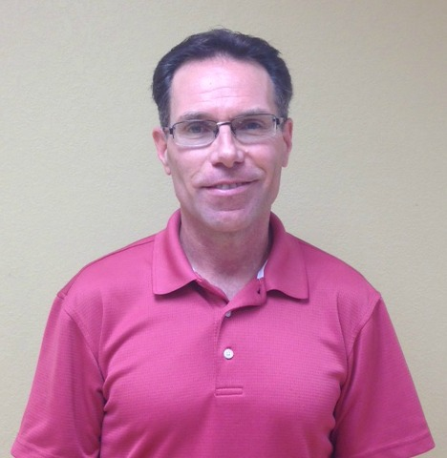

**“Love Is Stronger Than Hate”**

**Was the message a grieving dad gave to 1,000 people at his daughter’s funeral after she was brutally murdered in a DV incident. The Love > Hate Project was created from that message.1**

**“A Message From Jessie is real and graphic, a moving Call to Action.”2**

**“Dr. Buck is a dynamic speaker with a powerful message. Since Jessie’s passing, he works tirelessly to educate, motivate and inspire minds and hearts to add Love to our world and to end violence.”2**

**This will be a courageous presentation full of hope and insight.2**

**People are challenged to examine underlying belief systems and attitudes that result in intimate partner violence, and work to create change in them.**

**Stop The Silence:**

**End Domestic Violence**

**Featured Speaker:**

**Dr. Buck Blodgett**

**Executive Director**

**The LOVE > Hate Project**

**October 25th, 2018**

**7pm**

**Elgin Community College**

**Seigle Auditorium**

**Building E**

**University and Business Center**

**1700 Spartan Drive**

**Elgin, IL 60123**

**1.5 Free CEU’s for**

**LPC/LCPC, LSW/LCSW,**

**CDVP & CPAIP**

Directions once on the Elgin Community College campus:

Park in parking lot E and enter into building E

For more information please contact:

Community Crisis Center

847-697-2380