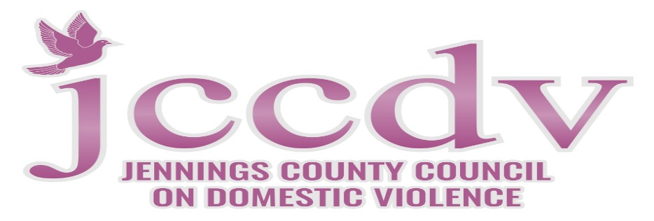

Support Group

When: September 11, 2018
Time: 2p.m. to 3p.m.
Where: JCCDV

Please call 812-346-1592 for directions if needed. All domestic violence survivors past and current are welcome to attend! Refreshments will be provided.

