Wrapped in Love Yarn-Cutting Celebration
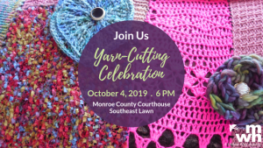
Just as Middle Way House wraps survivors of domestic violence,
sexual violence, and human trafficking in warmth and support,
teams and individual fabric artists lovingly create tree sweaters
for dozens of downtown Bloomington trees. Each beautiful
tree sweater is sponsored by someone committed to
providing meaningful alternatives to living with violence.

Middle Way House staff, board, volunteers, and supporters
invite you to gather

on October 4th at 6 PM
on the southeast corner of the courthouse lawn

to recognize Domestic Violence Awareness Month
and to celebrate the opening of Wrapped in Love 2019-2020.

*FREE AND OPEN TO THE PUBLIC*

Learn more at MiddleWayHouse.org/events.

